Implementing CRM for result tracking of a candidate with internal marks.

Create an object

## **Salesforce Objects**

[**Salesforce**](https://intellipaat.com/blog/what-is-salesforce/)objects are database tables that permit you to store data that is specific to an organization.

**Salesforce objects are of two types:**

* **Standard Objects:** Standard objects are the kind of objects that are provided by salesforce.com such as users, contracts, reports, dashboards, etc.
* **Custom Objects:** Custom objects are those objects that are created by users. They supply information that is unique and essential to their organization. They are the heart of any application and provide a structure for sharing data.

### **Properties of Custom Objects:**

* 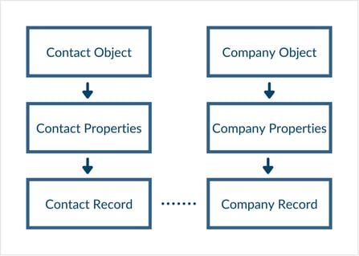**Custom fields**
* **Relationship to another object**
* **Page layouts**
* **Custom user interface tab**

Salesforce objects are database tables that permit you to store data that is specific to an organization. Salesforce objects are of two types: Standard Objects: Standard objects are the kind of objects that are provided by salesforce.com such as users, contracts, reports, dashboards, etc.

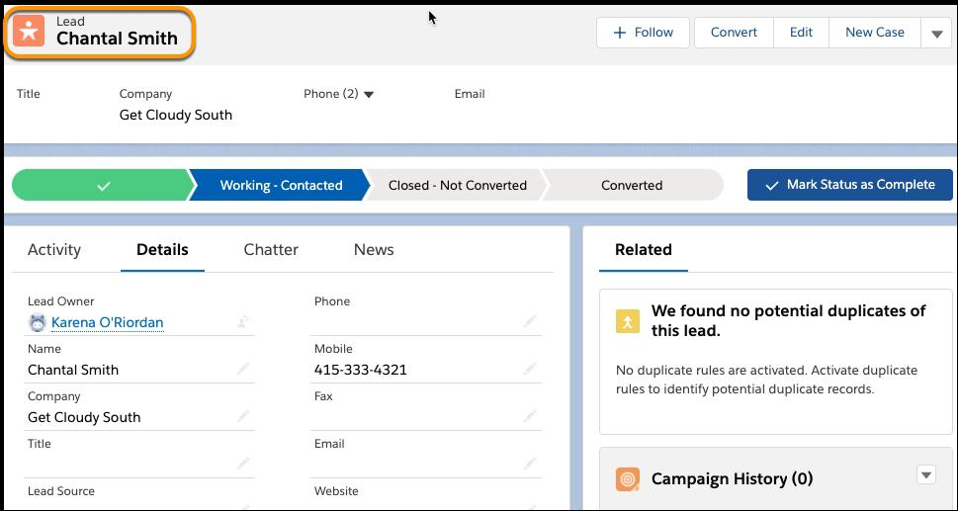

What is the use of create object?

Creating an Object

In

Java, the new keyword is used to cr

eate new objects. Declaration – A variable declaration with a variable name with an object type. Instantiation – The ‘new’ keyword used to create the object. Initialization – The ‘new’ keyword is followed by a call to a constructor.

Create an object

Click the candidate tap. click new to create a candidate record, enter a first and last name then click save to reveal the setup menu then select, edit page. This is a short cut to get into app builder and clone the default record page for the candidate object

